Dear colleagues!
We invite you to participate
in the international scientific and methodical
conference «Teaching of economic subjects
in terms of globalization and European
integration of Ukraine».
The conference will be held on June 02, 2017
at Business and Management Faculty of Kharkiv National Automobile and Highway University (KhNАHU).

Conference Topics (Sections)
1. Problems of development of educational subjects teaching methodology in terms of globalization and European integration of Ukraine.
2. Increasing the level of economic subjects teaching in terms of globalization and European integration of Ukraine.
3. Organization of independent and scientific work of students in the process of economic subjects teaching.
4. European and international experience in training of specialists in economics.
5. Novations in training in the specialty «International Economic Relations».

Conference working languages: Ukrainian, English, German, Polish, French and Russian.

Application for participation and theses should be submitted before May 01, 2017.

Conference Organizing Committee
Turenko Anatolii, Doctor of Technics, Professor, Rector, KhNАHU, Chairman of the Organizing Committee;
Bogomolov Victor, Doctor of Technics, Professor, Vice-Rector of scientific work, KhNАHU, Vice-Chairman of the Organizing Committee;
Dmytriiev Illia, Doctor of Economics, Professor, Dean of Business and Management Faculty, KhNАHU, Vice-Chairman of the Organizing Committee;
Gorovyi Dmytro, Doctor of Economics, Associate Professor, Head of International Economy Department, KhNАHU, Vice-Chairman of the Organizing Committee;
Boldovska Kateryna, Cand. Sci. (Econ.), Associate Professor, Vice-Head of International Economy Department, KhNАHU, Conference Coordinator;
Koralewski Jakub, PhD, Rector, Wyższa Szkoła
Hotelarstwa i Gastronomii, Poznan, Poland;
Parimal Chandra Biswas, Dr., Director of International Relations, Adamas University, Kolkata, India;
Paslavskyi Taras, Director of International Relations, Providence Group, Toronto, Canada;
Romanchuk Kateryna, Doctor of Economics, Associate Professor, Head of International Economy Department, Zhytomyr State Technological University;
Sanjay Kumar Bahl, PhD, Director-Principal, Sri Sai Institute of Management, Manawala, Amritsar, India.

The organizing committee should be grateful to you for informing colleagues and all interested
about this conference!

Terms of Participation in the Conference
For participation in the conference, scientists, doctoral candidates, graduate students, aspirants,
lecturers from institutions of higher education, experts in economics, representatives of state authorities and local self-government, financial and business structures and all persons interested in the conference topics
are invited.
Participation is free of charge.
Participants carry travel and accommodation costs at their own expense.
The conference lasts one day.

To participate in the conference you should submit an application of the sample:

Application form for participation
in international scientific and methodical conference «Teaching of economic subjects in terms of globalization and European integration of Ukraine»
Surname and name of participant (full name,
in Ukrainian and English)
Scientific degree
Academic rank
The full name and address of participant’s institution
Position
Title of the report
Number and name of the topic (section)
Scientific advisor
(for graduate students, aspirants)
Contact phone number, е-mail (necessarily)
Do you plan to arrive for participation in the conference (yes/no)
Date of filling application

By the results of the conference each participant will receive the collection of conference proceedings and the conference program as a PDF file for a self-printing.
Also the collection of conference proceedings
in electronic form will be accessible on the website
of International Economy Department of KhNАHU on the site of the university
http://fmab.khadi.kharkov.ua/kafedri/mizhnarodnoji-ekonomiki/naukovi-konferenciji.html
Requirements for Theses Execution
For publication in the collection of conference proceedings participants should submit theses of no more than 2 pages of A4 format (including literature).
Theses and application for participation are submitted in separate files in Word 2003 format (*.doc)
- the filename with the theses – the surname of the first
author and number of section (eg., Petrov2);
- the filename with the application – the surname of the first author, number of section and the word «application» (eg., Petrov2_ application);
Printing font – Times New Roman, font size – 14 pt, line spacing – single (1.0). Automatic hyphenation are excluded.
Page margins: up – 2.0 cm, down – 2.5 cm, left – 2.0 cm, right – 2.0 cm. Indent – 1.25 cm
The order of structural elements:
- in the top in the middle in capital letters in bold – title of the theses;
- below in one interval on the right in italics – initials and surname of the author(s), scientific degree and academic rank;
- below on the right in italics – full name of institution of the author(s);
- below in one interval – the body of report (theses);
- аt the end of the text in one interval – references.
Reference in the text to the source is being done by ordinal number in square brackets. When making a bibliography you should follow the requirements of MES of Ukraine and DSTU GOST 7.1: 2006
TITLE

I. Ivanov, Cand. Sci. (Econ.), Associate Professor
Kharkiv National Automobile and Highway University

Text …

References
1. …
Theses are published in author's edition.
Authors are responsible for the accuracy of the presented information.

Theses won't be considered in case of its fails requirements for execution and deadlines.

Contacts
Participants may submit the theses and application for participation in the conference in such ways:
1) to send by e-mail: ie_khnahu@ukr.net
(the confirmation of materials receipt you should receive in response within 3 working days)
2) to give the conference coordinator personally by appointment at the following address:
Kharkiv, Vladyslav Zubenko str. 3а (the former name Tymurivtsiv), Business and Management Faculty of KhNАHU, room 156.

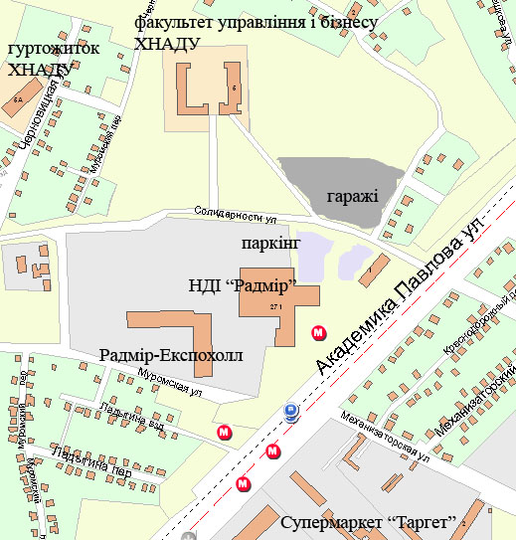

If you have questions please contact ONLY from 11:00 to 18:00 to
Vice-Chairman of the Organizing Committee: Gorovyi Dmytro – Doctor of Economics, Associate Professor, Head of International Economy Department of KhNАHU by tel. +38-097-39-39-847,
+38-050-915-15-48.
Conference Coordinator: Boldovska Kateryna – Cand. Sci. (Econ.), Associate Professor of International Economy Department of KhNАHU by tel. +38-050-708-79-32, +38-057-738-77-86.

Ministry of Education and Science of Ukraine

Kharkiv National Automobile and Highway
University
in collaboration with

Zhytomyr State Technological University (Ukraine)
Providence Group (Торонто, Канада)
Wyższa Szkoła Hotelarstwa i Gastronomii
(Poznan, Poland)
Adamas University (Kolkata, India)
Sri Sai Institute of Management, Manawala
(Amritsar, India)

Kharkiv, Ukraine

